Bond angles and shapes
OCR B Specification:
- ​Chemical bonding in terms of electrostatic forces; simple electron ‘dot-and-cross’ diagrams to describe the electrons' arrangements in ion and covalent and dative covalent bonds.
- Use of the electron pair repulsion principle, based on a ‘dot-and-cross’ diagram to predict explain, and name the shapes of simple molecules (such as BeCl2, BF3, CH4, NH3, H2O, and SF6,) and ions (such as NH4 ) with up to six outer pairs of electrons ( any combination of bonding pairs and lone pairs); assigning bond angle to these structures.
​
Dot-and-Cross diagram:
​
The Dot cross diagram is a diagram used to show the outer shell electrons in orbitals around an atom or compound. The electrons can be represented by any shape such as a dot, cross, square, and many more.

This is the outer shell of chlorine:
+
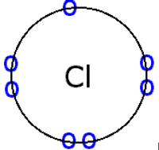
As you can see there are 7 electrons in the outer shell when it is not bonded to anything else.
​
When chlorine is bonded with another chlorine it produces a covalent bond which is represented like this:
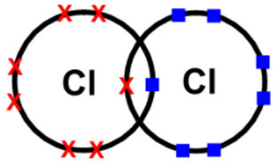
As you can see, one of the electrons in each chlorine atom shares its electron with the other one to produce a full outer shell. This happens because the two electrons are localized between the nuclei of the bonded atoms furthermore, the electrostatic attraction between the negatively charged bonding electrons and the positively charged nuclei holds the atoms together strongly.

Dative Covalent Bonds:

We can sometimes represent molecules like this:
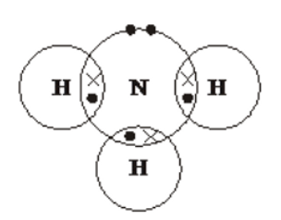
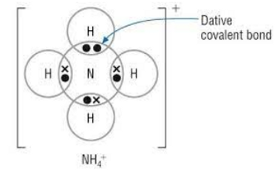
As you can see nitrogen has a lone pair of electrons. This means that a hydrogen ion (H ) can share the nitrogen's electrons forming a dative covalent bond. A dative covalent bond has been formed due to the hydrogen sharing two of the nitrogen's electrons forming a positively charged ion. This type of bond is called dative covalent bond and can be shown with an arrow → when doing it without the dot-and-cross. This means that the electrons are shared from the same bonding pair of the atom.

Bond angles:

Key points to note:

- From the dot-and-Cross diagram the total amount of electron density determines the corresponding bond angle and its shape.

- If a compound contains a lone pair, this will slightly change the bond angle as the lone pair will repel more strongly in comparison to bonded pairs.

- The total number of bonding pairs and lone pairs determine the corresponding bond angle and shape as well.
​
Let’s look at each shape individually with some examples… (Please note that you have to write this when describing the shape to get the full makes)
​
Linear:
For example: BeCl2
+

This molecule has 2 areas of electron density around the central ‘Be’ that will repel as far as possible. This would give a bond angle of 180° and the shape will be Linear.

N.B: You can also say that this molecule has 2 bonded pairs of electrons that repel as far as possible.

So therefore 2 bp + no lone pairs= Linear

3D Shape:
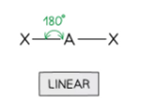
Trigonal Planar:
For example: BF3
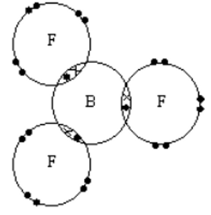
BF3 has 3 areas of electron density that repel as far as possible around the central Boron, hence giving a bond angle of 120° and a shape Trigonal Planar.

N.B: You can also say that this molecule has 3 bonded pairs of electrons that repel as far as possible hence giving a shape of trigonal planar.

so therefore, 3 bp + no lone pairs = Trigonal Planar

3D Shape:
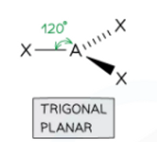
Tetrahedral:
For example: CH4
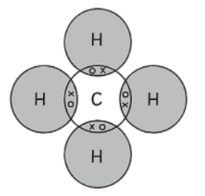
CH4 has 4 areas of electron density that repel as far as possible around the central Carbon hence giving a bond angle of 109.5° and shape to be Tetrahedral.

N.B: You can also say that methane has 4 bonding pairs of electrons that repel as far as possible hence giving the shape of Tetrahedral.

So, therefore 4 bp + no lone pairs = Tetrahedral

3D Shape:
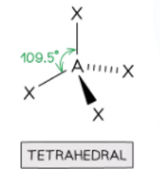
Pyramidal:
For example: NH3
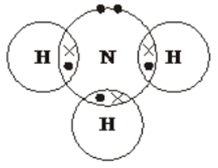
NH3 has 4 areas of electron density that repel as far as possible around the central Nitrogen. Ammonia also has 1 lone pair that will repel more strongly compared to the bonding pair hence giving a bond angle of 107° and a Pyramidal shape.

N.B: You can also say that Ammonia has 3 bonding pairs and 1 lone pair that repel as far as possible. Lone pairs repel more strongly in comparison to bonding pairs hence giving an angle of 107° and a shape of Pyramidal.

3D Shape:
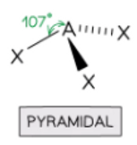
Bent/Angular:
For example: H2O
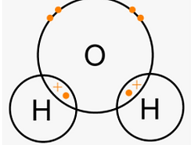
H2O has 4 areas of electron density that repel as far as possible around the central Oxygen. It also has 2 lone pairs that will repel more than the bonding pairs hence giving a bond angle of 104.5° and the shape to be Bent/Angular.

N.B: You can also say that water has 2 bonding pairs and 2 lone pairs that repel as far as possible.
So, therefore 2bp + 2 Lp = Bent/angular

3D Shape:
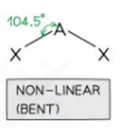
Trigonal bipyramidal :
For example: PF5
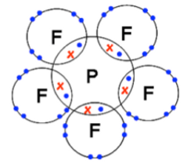
PF5 has 5 areas of electron density that repel as far as possible around the central Phosphorus, hence giving a bond angle of 90° and 120° and the shape to be Trigonal bipyramidal.

N.B: You can also say that this molecule has 5 bonded pairs that repel as far as possible hence giving a bond angle of 90 and 120° and shape of trigonal bipyramidal.
3D Shape:
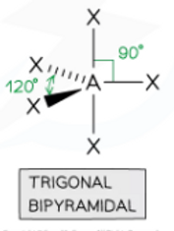
Octahedral:
For example: SF6
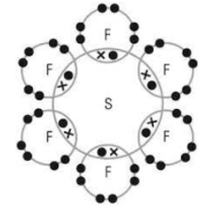
SF6 has 6 areas of electron density that repel as far as possible around the central Sulphur, hence giving a bond angle of 90° and a shape to be Octahedral.

N.B: You can also say that this molecule has 6 bonded pairs of electrons that repel as far as possible hence giving the shape Octahedral and bond angle of 90°

So, therefore 6 bp = Octahedral
3D Shape:
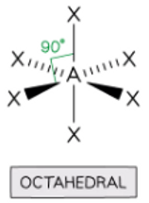
Summary:

-Linear is 2 bonded pairs = 180°
-Trigonal planar is 3 bonded pairs. = 120°
-Bent/Angular is 2 bonded pairs with 1 lone pair. = 104.5°
-Pyramidal is 3 bonded pairs with 1 lone pair. = 107°
-Tetrahedral is 4 bonded pairs. = 109.5°
-Trigonal bipyramidal is 5 bonded pairs. = 90° + 120°
-Octahedral is 6 bonded pairs. = 90°
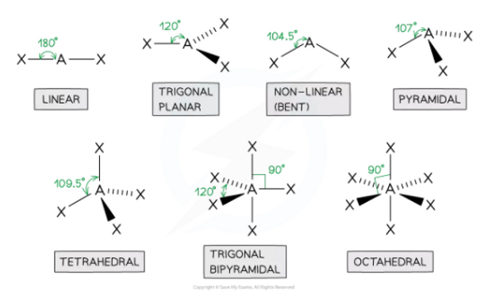

Author: Lara Guiet

