History of the Atom:

***The spec*** *- how knowledge of the structure of the atom developed in terms of a succession of gradually more sophisticated models; interpretation of these and other examples of such developing models.*

Ideas about the atom and its structure have changed overtime. Different scientists have continually developed new atomic **models** as new experimental evidence was brought to light, until eventually the atomic model we know today was developed.

**1803 – John Dalton**

Published the idea that all matter was made of tiny particles called atoms. These **atoms are spheres** that could not be divided, and each element is made from different spheres.

**1897 – J.J.Thomson**

T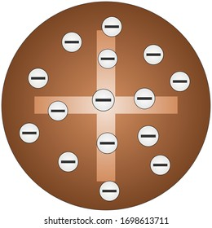homson carried out experiments which led him to **discover the electron,** this finding led to his suggestion of the plum pudding model of the atom. In this model, the atom is a ball of positive charge with electrons embedded in it, similar to the currants embedded in a Christmas pudding.

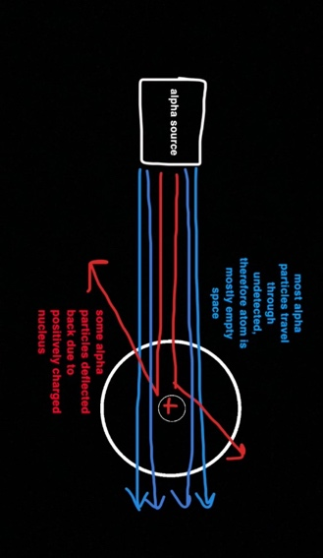

**1909 – Ernest Rutherford**

Rutherford designed an experiment to test the plum pudding model which led to the **discovery of the** **nucleus.** This experiment is known as the ‘alpha scattering experiment’. Positively charged alpha particles were fired at a thin gold foil surrounded by a fluorescent screen. From his observations, he found that most alpha particles went straight through the gold foil, but occasionally a small number of alpha particles were deflected backwards. Since most particles passed through undeflected, this led to the conclusion that the atom was mainly empty space. As well as this, since some particles deflected this suggested that the nucleus in the center of the atom was very small and positively charged.

**1913 – Niels Bohr**

Bohr then discovered a problem with Rutherford’s model. He realized that the cloud of electrons could collapse into the positive nucleus. Therefore, he proposed electrons were in **fixed energy shells.**  There is experimental proof to show this as when EM radiation is absorbed, electrons move between shells, they emit this radiation when electrons move down to lower energy shells.He also did experiments that led to the idea that the nucleus contained small positively charges particles called **protons.**

**1932: James Chadwick**

Bohr and other scientists knew that there also had to be a neutral particle the same size as a proton to keep the nucleus stable and to make up the mass however was not able to prove it yet. However, In 1932, James Chadwick bombarded beryllium atoms with alpha particles. An unknown radiation was produced. Chadwick interpreted this radiation as being composed of particles with a neutral electrical charge and the approximate mass of a proton. This particle became known as the neutron. From his finding of the neutron, he found that it had a mass of 1 but carried no overall charge.

**The Atom Today**

An atom has a central nucleus, and this is surrounded by negatively charged electrons arranged in shells. The nuclei of atoms contain subatomic particles, positively charged protons and neutrons with a neutral charge. The nucleus of the atom is where most of the mass is concentrated.

